THE 35th ANNUAL
SOUTHERN STATES CORVETTE FESTIVAL !

Hosted by
The Oklahoma City Corvette Club
The Corvette Club of Oklahoma City
May 25,26, & 27, 2007!
RACE FEVER!!!!

LODGING: We have reserved a block of 35 rooms at the Quality Inn located at 7800 C.A. Henderson Blvd., Oklahoma City, OK, which is on the south side of I-240 between Western and Pennsylvania. This is the same hotel as years past. We’ve being given a special rate of $50 per night with room occupancy of up to four people. The Quality Inn will hold this block of rooms for us through May 19th, 2006. To make reservations, call (405) 632-6666 and be sure and mention that you’re with the Corvette group for those dates and rates.

REGISTRATION: Friday, May 25th, from 6:00 PM to 9:00 PM at the Quality Inn and before each scheduled event at the event location. Naturally, we prefer that you pre-register by mail for all the events (and save yourself some bucks). Forms must be postmarked by May 18th, 2007 for pre-registration! NOTE: To insure a quality event we will be limiting autocross entrants to the first 80 complete packages received!!

HOSPITALITY: The OKC Club has reserved a Hospitality Room for Friday and Saturday nights. We will have the usual snacks, soft drinks and adult beverages. FTD Awards will be presented in the hospitality room at 9:00 pm Saturday. Note: We will be providing lunch tickets for both Saturday and Sunday redeemable at the track.

TECH: Because we always have a great turnout for our autocross, we request that if you’re at the Quality Inn Friday night, please tech your car then. Tech will be open from 6:00 PM to 9:00 PM Friday at the hotel, then Saturday morning from 7:45 to 8:30 AM at the Sheriff Training Center, and 8:00 AM to 9:00 AM at Thunder Valley on Sunday. Friday evening will be the best time to get your Corvette teched, for all of us!

SATURDAY, MAY 26th, Oklahoma County Sheriff Facility:
Gates open at 730 AM
Registration is Saturday morning from 7:45-8:30 AM at the Sheriff Track at the corner of NE 36th and Air Depot. Watch your speed on NE 36th the locals do patrol and they will write you a ticket.
.
Autocross: Driver’s meeting at 8:45 AM with the first car out at 9:00 AM. The Track is a road course used for training local Law Enforcement Personnel. That will allow us to setup a fast and challenging course for everyone’s enjoyment. We will run six full autocrosses and plan to have everyone back to the hotel by 5:30 PM. See course map below…

NOTE: TO INSURE A QUALITY EVENT WE WILL BE LIMITING AUTOCROSS PARTICIPATION TO THE FIRST 80 COMPLETE PACKAGES RECEIVED!!!
SUNDAY, MAY 27TH, THUNDER VALLEY RACEWAY PARK:
Gates open at 7:30 AM, Registration will be open from 8:00 till 9:00.
Matching Times, Record, & Two E.T. Drags: Time trials start as soon as your Corvette is teched and will end at 10:00 AM with the driver’s meeting at 10:15 AM. Matching Times Drags will be a separate event, not part of time trials. You will get plenty of drag racing this weekend. We have the track all day this year!! For Record Drags there will be an impound area and all Group I and Group II cars must enter the impound area after they have run under the record.
NOTE: Thunder Valley requires that all participants wear long pants!

AWARDS: All Entrants will receive a special, custom plaque engraved after the event with your name, class, and finish in each of the 10 events, shipped to your home. When you fill out your registration sheet, please take care when entering your address; this is where your award will be shipped. Awards will also be presented for the Autocross Top FTDs Saturday at 9:00pm in the hospitality room, for and to the Men’s and Women’s Top Eliminator following the drags Sunday. Also, our Legendary Festival T-Shirts will be on sale through out the weekend, please check with the ladies at registration for your size. The price will be $12.00.
Special Offer: If you would NOT like to receive an award
and would like to save a few dollars, we are offering
a “NO AWARD” registration price for pre-registration packages only.

Note: NO alcoholic beverages are allowed at Thunder Valley Raceway Park or the Sheriff Training Center during the event.
BRETT RUSTON, GOVERNOR
800 OLD BUGLE RD
EDMOND, OK 73003
(405) 285-1119
QUALITY INN, HOST HOTEL
I-240 & WESTERN
OKLA. CITY, OK
(405) 632-6666

OKC’s latest edition is a driver training center for the County Sheriff’s department.
Over a mile in length, smooth, fresh blacktop.
Very challenging, very, very fast!!!

HOWEVER, tow rigs/trailers will have to park in the grass. Once your car is in staging, it will be very difficult to get back to your rig…plan accordingly.
THUNDER VALLEY RACEWAY PARK
This facility needs no introduction to regular SW Region drag racers. Full, 100%, concrete ¼ mile!!
All 4 events are separate, plus plenty of time trials.
If you never get enough runs during the day, this is the event for you!!!
NATIONAL COUNCIL OF CORVETTE CLUBS, INC.
Southern States Corvette Festival
Sanction # SW 2007-(5 - 10) Type of Event: Low Speed Autocross #1,2,3,4,5, &6

Date: May 26, 2007 Club: CCOC/OCCC

Registration : Opens 7:45 AM Closes 8:30 AM Region: Southwest
Autocross Drivers Meeting Time: 8:45 AM Autocross $20 ea
First Car Out Time: 9:00 AM Location Description:

Oklahoma County Sheriff Training Center
NE 36th and Air Depot
I-240
I-40
Downtown
OKC
I-35
I-35 North
NE 36th
Track
Track is 3 miles EAST of I-35
3 miles north of I-40
20 minutes from host hotel
Air Depot Blvd does not go through to I-40, use NE 36th.
Host Hotel
Exhaust: Open Closed XX OKC, OK.
Speed Events: Hi Low XX

Event Chairman: Governor:
Name: Mike Hoehn / Ron Ruston Name: Mike Hoehn / Brett Ruston
Address: 13000 Red Eagle Pass Address: 13000 Red Eagle Pass
Edmond, OK 73013 Edmond, OK 73013
Phone: (405) 478-2439 Phone: (405) 478-2439
Note: In a high-speed event, all roadsters must have roll bars as outlined under Section on Technical Inspection for Speed Event. It is highly recommended that all competing cars be equipped with rollbars at high-speed events. Fire extinguisher (min. 5BC) required in all groups and classes at high-speed events.

NATIONAL COUNCIL OF CORVETTE CLUBS, INC.
Southern States Corvette Festival
Sanction # SW 2006, (1-4) Type of Event: Drags (Rec, E.T. #1 & #2, M.T.)
Date: May 27, 2007 Club: OCCC
Registration : Opens 8 AM Closes 9 AM Region: Southwest
Drivers Meeting Time: 10:15 AM Entry Fee Record Drags $30 ET Drags $30 ea.
MT Drags $20

First Car Out Time: 10:15 AM Location Description:

Thunder Valley Raceway Park
Noble, Ok.
Exhaust: Open XX Closed
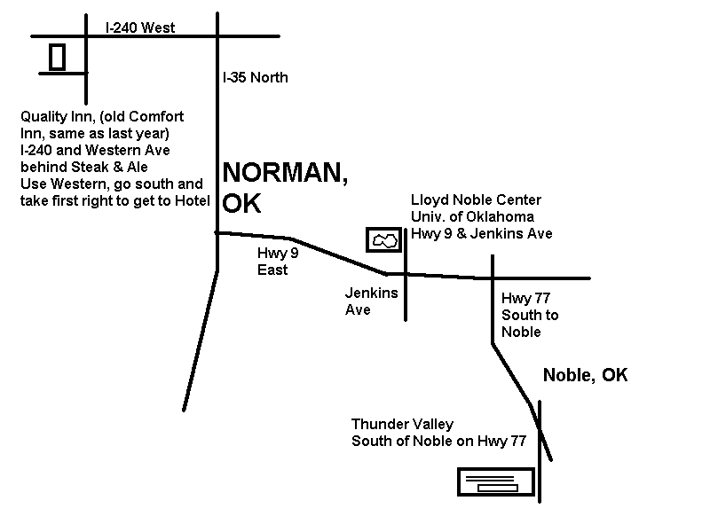Speed Events: Hi XX Low
Event Chairman: Governor:
Name: Alan Brown Name: Brett Ruston
Address: 1220 Kingston Ct. Address: 800 Old Bugle Rd.
Edmond, OK 73034 Edmond, OK 73003
Phone: (405) 359-1413 Phone: (405) 285-1119
Note: In a high-speed event, all roadsters must have roll bars as outlined under Section on Technical Inspection for Speed Event. It is highly recommended that all competing cars be equipped with rollbars at high-speed events. Fire extinguisher (min. 5BC) required in all groups and classes at high-speed events.

SOUTHERN STATES CORVETTE FESTIVAL 2007
Primary Registration: Drag Auto-X Preferred
Name Class: Class: Car# :

Address
City State Zip
Name of Club NCCC#
Telephone (Home) Work
Secondary Registration: Drag Auto-X Preferred
Name Class: Class: Car# :
Address

City State Zip
Name of Club NCCC#

Telephone (Home) Work

Notify in case of Emergency—Name Number

Please give us you email address we will be confirming your registration and we will email the results_______________________________________

MAKE CHECK PAYABLE TO: The Oklahoma City Corvette Club or OCCC
MAIL COMPLETE FORM AND CHECK TO:
Brett Ruston 800 Old Bugle Rd. Edmond,OK 73003 (405) 285-1119)
ENTRY MUST BE POSTMARKED BY: MIDNIGHT MAY 18, 2006 NO REFUNDS ON DRAGS

EVENTS | FEE | PRIMARY | SECONDARY | TOTAL
AUTOCROSS #1 Saturday | $20
AUTOCROSS #2 Saturday | $20
AUTOCROSS #3 Saturday | $20
AUTOCROSS #4 Saturday | $20
AUTOCROSS #5 Saturday | $20
AUTOCROSS #6 Saturday | $20
AUTOCROSS PKG (Pre-Registration Only!) | $90
AUTOCROSS PKG  (Pre-Registration Only!) “NO AWARD” Special | $75
RECORD DRAGS Sunday | $30
E.T. BRACKET DRAGS I Sunday | $30
E.T. BRACKET DRAGS II Sunday | $30
MATCHING TIMES DRAGS Sunday | $20
DRAG PACKAGE (Pre-Registration Only!) | $90
DRAG PACKAGE (Pre-Registration Only!) “NO AWARD” Special | $75
WEEKEND PACKAGE 10 Events and Special Awards !!!  Pre-Registration Only | $135
SPECIAL “NO AWARD” PACKAGE Pre-Registration Only | $120

TOTAL
Note: We are limiting autox participation to the first 80 complete packages!!!

