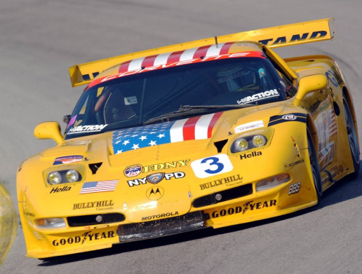
MID TEXAS CORVETTE CLUB & LONGHORN CORVETTE CLUB
Cordially Invite You to the
FIBERGLASS FEVER & REGION ROUNDUP AUTOCROSSES
JULY 7 & 8, 2007

Join the Mid Texas Corvette Club and the Longhorn Corvette Club for a fun filled 11 autocross weekend held at the Belton High School Parking lots in Belton, Texas. This site provides a shaded area for viewing and scoring. Entrants will be provided free lunch tickets, water, and will receive an event Tee shirt.

LODGING: Comfort Suites Killeen, a brand new hotel at 2709 Cunningham Rd and Hy 190, The hotel faces the eastbound frontage road across a small field just past Logan’s Roadhouse. If coming from east, exit at JS Young, circle under to the eastbound frontage, go a block past Logan’s, turn right on Cunningham. There is room in back for trailers. A block of rooms at $75 will be held through June 22. To make reservations, call 1-(254)-634-5560 or e-mail gmtx959@choicehotels.com Mention that you are with the Corvette Club. There’s a brand new pool waiting for a party.

HOSPITALITY, REGISTRATION & TECH: Friday, July 6 from 6:00pm to 10:00pm at the Comfort Suites Killeen. Hospitality and registration, with snacks and beverages, will be in the large clubroom facing the pool in the rear of the hotel. Tech will be in the rear lot. Sat & Sun, 6:30am to 8:00am at the track location. We prefer that you pre-register by mail or online at www.longhorncorvette.com for the weekend. To receive the early discount, Registration forms must be postmarked or received online no later than June 23, 2007. Major Credit Cards are accepted.

AUTOCROSSES: Sat & Sun: Driver’s meetings at 8:15 a.m. with the first car out by 8:30 a.m. On Saturday, we will run (6) autocrosses, (5 being MTCC’s and 1 being LCC’s) and (5) LCC autocrosses on Sunday so folks can get away at a reasonable hour. Be ready for a fun time!!

For more information or questions, contact:
Joe Denham, MTCC Governor @ (254) 466-0406 jscdesigns@hot.rr.com
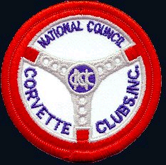
George MacDonald, LCC Chairman @ (512) 863-9733 macd601@verizon.net
Tom Moore @ (512) 255-2360 quikvette@peoplepc.com

NATIONAL COUNCIL OF CORVETTE CLUBS, INC.
MID TEXAS CORVETTE CLUB (MTCC)
Annual Fiberglass Fever 2007

Sanction (MTCC) # SW185- 083 thru 087 Type of Event: Low Speed Autocross #1,2,3,4,5

Date: July 7, 2007 Club: Mid Texas Corvette Club (SW-185)
Registration: Opens: 7:00 am Region: Southwest
Closes: 8:00 am
Drivers Meeting Time: 8:15 am Entry Fee:__$16.00_________
First Car Out Time: 8:30 am Location Description: Belton High School: 600
Lake Rd. Belton Texas

Exhaust: Open_____ Closed XX
Speed Events: Hi ___ Low XX

Map and Event Information: Directions: Take I-35 to Belton, Texas. Exit on 190 west to Killeen. Exit
Hwy 190 at Loop 121. Turn right (north) on 121 and go approx 3 miles. Turn left at the Sparta Road
traffic light just over the railroad overpass. The High School parking lot will be on your right behind the
Belton Middle School building.
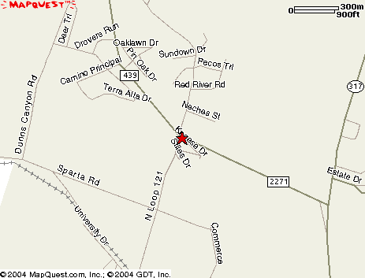

Overall Event Chairperson: Joe Denham, SW-185-0129.

Governor: Joe Denham, 3402 Oakridge Blvd, Harker Heights Texas, 76548.
E-Mail: jscdesigns@hot.rr.com.
Phone: (254)-466-0406.

NATIONAL COUNCIL OF CORVETTE CLUBS, INC.
LONGHORN CORVETTE CLUB INC.
REGION ROUNDUP, 2007

Sanction # SW-207-088 (Saturday) Type of Event:Low Speed Autocross # 11
Sanction # SW-207-078 thru 082 (Sunday) Type of Event: Low Speed Autocross #6,7,8,9,10

Date: July 7, 8, 2007 Club: Longhorn Corvette Club (SW-207)
Registration: Opens: 7:00 am Region: Southwest
Closes: 8:00 am
Drivers Meeting Time: 8:15 am Entry Fee:__$16.00____
First Car Out Time: 8:30 am Location Description: Belton High School 600
Lake Rd. Belton Texas.

Exhaust: Open_____ Closed XX
Speed Events: Hi ___ Low XX

Map and Event Information: Directions: Take I-35 to Belton, Texas. Exit on 190 west to Killeen. Exit Hwy 190 at Loop 121. Turn right (north) on 121 and go approx 3 miles. Turn left at the Sparta Road traffic light just over the railroad overpass. The High School parking lot will be on your right behind the Belton Middle School building.

Overall Event Chairperson: George MacDonald SW-207-1023
E-Mail: macd601@verizon.net
Phone: (512) 863-9733

Governor: John Tiemann, 9303 Honeycomb Dr, Austin, TX 787-1118
E-Mail: john_tiemann@amat.com
Phone: (512) 288-0151

NATIONAL COUNCIL OF CORVETTE CLUBS, INC.
MID TEXAS CORVETTE CLUB, (MTCC) Fiberglass Fever
LONGHORN CORVETTE CLUB, INC REGION ROUNDUP 2007

Primary Registration:
Name Class: Permanent Car #
Address
City State Zip
Name of Club NCCC #
Telephone (Home) e-mail address
Secondary Registration:
Name Class Permanent Car #
Address
City State Zip
Name of Club NCCC#
Telephone (Home) e-mail address
Note: For prompt delivery of event results, please include your e-mail address if applicable.

EVENTS Mid-Tex Corvette Club | FEE | PRIMARY | SECONDARY | TOTAL
Autocross #1 Saturday | $16
Autocross #2 Saturday | $16
Autocross #3 Saturday | $16
Autocross #4 Saturday | $16
Autocross #5 Saturday | $16
Autocross #11 Saturday (LCC Autocross) | $16
SATURDAY only PKG (Pre Reg. Only) | $80
EVENTS Longhorn Corvette Club | FEE
Autocross #6 Sunday | $16
Autocross #7 Sunday | $16
Autocross #8 Sunday | $16
Autocross #9 Sunday | $16
Autocross #10 Sunday | $16
SUNDAY only PKG (Pre Reg. Only) | $68
WEEKEND EARLY REGISTRATION  ALL 11 EVENTS | $145
ON SITE OR LATE REGISTRATION $176
Early Registration: Must be postmarked or e-mailed by June 23, 2007 to obtain early or
pre-registration discount.
On-Line registration: www.longhorncorvette.com
Make checks payable to: Longhorn Corvette Club, Inc.
Mail registration to: Ron Alm, Treasurer
Longhorn Corvette Club, Inc.
P.O. Box 12084
Austin, TX 78711-2084 Ron’s phone > (512) 258-8767

