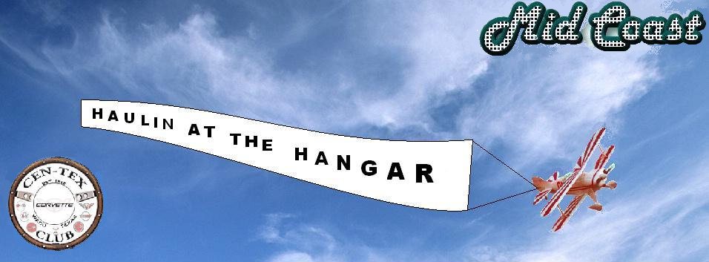

Cen-Tex and Mid-Coast Corvette clubs would like to invite everybody to their NCCC event for 2007. Come to Waco and join us for 14 low speed autocrosses at the TSTC airport on May 19 and 20. As always, we will do our best to maintain a fast, cone free, fun-filled course.
We will start Friday night with hospitality and tech inspection until 9:00 PM at the hotel. After tech, you will be able to leave your rig at the track on Friday night. Gates will be locked at 6:00PM for your security. After 6:00, you can still leave your rig outside the gates at the track. Only those who complete registration and tech inspection Friday night at the hotel will be eligible for the door prize raffle. The raffle will be held Saturday morning during the drivers meeting.
We will be providing an indoor, sit-down lunch Saturday and Sunday, which is included in the complete weekend registration package. During registration, you will be handed your lunch vouchers, so hang on to them, or you’ll go hungry. Non-drivers can purchase lunch for $5.
Each day we will complete the 7 autocrosses as efficiently as possible, to allow you plenty of time for relaxation and celebration. The drivers meeting starts at 8:00 AM. The first car on the track by 8:15.
The hotel is Super 8 located at 1320 Jack Kultgen Freeway (I35) in Waco. The rates are $54.95 per night. Ask for the block reserved for the Corvette Club. We will release the rooms on May 15, so please plan ahead. Hospitality and tech inspection will be available at the hotel. The Super 8 phone number is 254-754-1023.
Please remember, no smoking, alcohol, or unattended children in the hangar. If George W is in town, an alternate location for the autocross will be used.

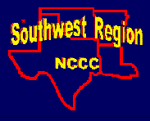
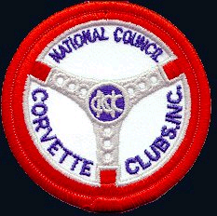

NATIONAL COUNCIL OF CORVETTE CLUBS, INC.
CEN-TEX and MID-COAST CORVETTE CLUB
Sanction # SW-2007-22 through SW-2007-35
Type of Event: LS Autocross #1,2,3,4,5,6,7,8,9,10,11,12,13,14
Date: May 19th & 20th, 2007 Clubs: Cen-Tex and Mid-Coast
Registration: Opens 7:00 AM Closes FCO
Region: Southwest
Drivers Meeting Time: 8:00 AM Entry Fee $13
First Car Out Time: 8:15 AM Location Description: TSTC Airport

Waco, TX

Exhaust: Open Closed XX
Speed Events: Hi Low XX

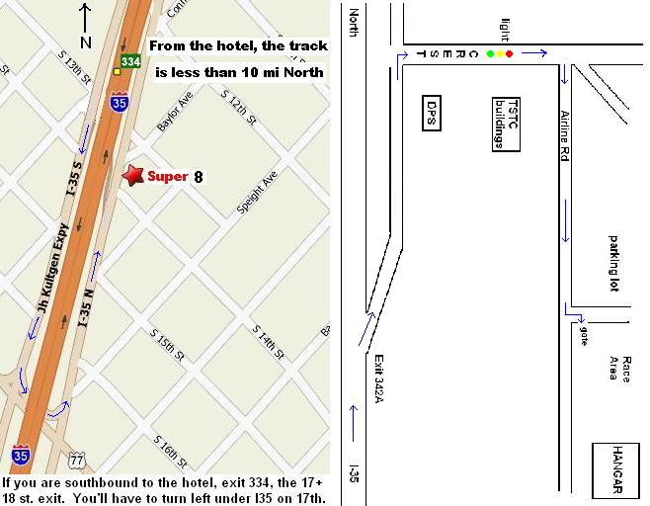

Event Chairman: Governor:
Name: Jerome Carter Name: Jason Franklin
Phone: (254) 863-5600 Phone: (254) 722-3852
Note: In a high-speed event, all roadsters must have roll bars as outlined under Section on Technical Inspection for Speed Event. It is highly recommended that all competing cars be equipped with rollbars at high-speed events. Fire extinguisher (min. 5BC) required in all groups and classes at high-speed events.

Driver 1:
Name Class: SW Region Perm. Car# :
Address
City State Zip
Name of Club NCCC#
Telephone (Home) Work

If you have a permanent regional or preferred car# please provide it.

Driver 2:
Name Class: SW Region Perm. Car# :
Address
City State Zip
Name of Club NCCC#

Telephone (Home) Work

MAKE CHECK PAYABLE TO: Cen-Tex Corvette Club
MAIL COMPLETE FORM AND CHECK TO: Joe Reese 312 Warren Rd. Lorena,Texas 76655
EARLY REGISTRATION MUST BE POSTMARKED BY: May 5, 2007

Events | Day | Fee | Driver 1 | Driver 2 | Total
Autocross #1 | Saturday | $13
Autocross #2 | Saturday | $13
Autocross #3 | Saturday | $13
Autocross #4 | Saturday | $13
Autocross #5 | Saturday | $13
Autocross #6 | Saturday | $13
Autocross #7 | Saturday | $13
Autocross #8 | Sunday | $13
Autocross #9 | Sunday | $13
Autocross #10 | Sunday | $13
Autocross #11 | Sunday | $13
Autocross #12 | Sunday | $13
Autocross #13 | Sunday | $13
Autocross #14 | Sunday | $13
Early Discount Package |  | $130
TOTAL

TO QUALIFY FOR EARLY REGISTRATION DISCOUNT, ENTRY FORMS MUST BE POSTMARKED
BY MAY 5, 2007- NO EXCEPTIONS

If you would like your results emailed to you, please check “YES” and complete the address information.
Yes |  | No |  |  | Email address: |  |  |  | ___

Please print clearly

