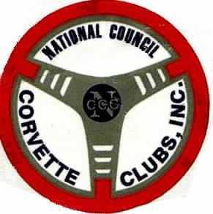
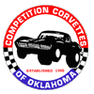
COMPETITION CORVETTES
OF OKLAHOMA
Oklahoma Thunder 2007
April 20th, 21st & 22nd

CCO wishes to invite you to Oklahoma Thunder 2007, April 20TH, 21st & 22nd, 2007. We will be racing at Hallett Motor Racing Circuit and Tulsa Raceway Park, site of the 1985 NCCC National Convention.

The Southwest Region has been selected to host the 2008 NCCC National Convention at the same locations. This could be your chance to get in some valuable track time prior to the convention.

At Hallett, we will be hosting a Play Day and High Speed Driving School, running lapping sessions on Friday, which is always sponsored by Credit World Auto Sales. On Saturday, we will be running two High Speed and one Low Speed event at Hallett. Gates open at 6:30 on both days, with drivers meeting at 8:30. Sunday, there will be two E.T. Drags and one Record Drag event at Tulsa Raceway Park. Gates will open at 8:00 with time trials starting as soon as track conditions permit. Time trial will end at 10:15 with the beginning of the drivers meeting for the racing events.

T Shirts will be available for purchase at the various event locations.

The Driving School is new for this year. We will offer classroom instruction as well as several lapping sessions with one-on-one instruction with some of the Southwest Region’s best teachers & drivers. When you successfully complete the school you will receive your High Speed Certification. If you’re already certified, and would like to attend the school, that will also be available.

Hallett Motor Racing Circuit is a 1.8, 10-turn Road Racing course, with varying grade elevation changes, located 35 miles west of Tulsa, Oklahoma, on the Cimarron Turnpike.

Tulsa Raceway Park is an IRHA approved drag strip that since 2003 has undergone total renovation including complete renovation of the strip and construction of a new 3000 sq.ft. Timing tower. It is located at 3101 N. Garnett Rd. in Tulsa, Oklahoma.

The host hotel will be the Baymont Inn located at 4530 E. Skelly Dr. in Tulsa. The Hotel is located at the SW Corner of I-44 and Yale Ave behind Don Pablo’s and Celebration Station. The phone number is 918-488-8777. Tell them you are with the "Corvette Club" for your special rate of $48.00 per night.

Due to trying to keep event costs down, the only awards that will be presented for the weekend will be the "Ivan Brown·-Turn 4" award, and the "E. H. Cauthen" award.

Be sure to come join us for a great weekend of racing. SEE YA’ll AT THE TRACK!! !!

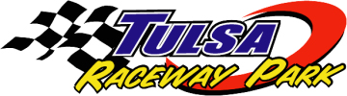

OKLAHOMA THUNDER 2007
REGISTRATION FORM

Preferred entrant # and class???

DRIVER #1________ CLASS________DRIVER #2_______CLASS_______

E-Mail Address:_________________________________

DRIVER #1______________________ NCCC#___________________

ADDRESS__________________________________CITY/STATE/ZIP__________________

PHONE____________________________ CLUB_______________________

DRIVER #2______________________ NCCC#___________________

ADDRESS__________________________________CITY/STATE/ZIP__________________

PHONE____________________________ CLUB_______________________

EVENT Entered Early Reg Late Reg Total

SATURDAY
Low Speed #1 $25 $35 =
High Speed #1 $35 $45 =
High Speed #2 $35 $45 =

SUNDAY
ET Drag #1 $20 $30 =
ET Drag #2 $20 $30 =
Record Drag $15 $25 =
__________________ Total Amount Due

MUST BE POSTMARKED NO LATER THAN APRIL 12, 2007 TO RECEIVE EARLY REGISTRATION PRICES.

Make checks payable to Competition Corvettes of Oklahoma. No refunds after April 16, 2007.
Send checks w/registration form to: Linda Lewis, 19005 East Pine, and Catoosa, OK 74015

Please refer all questions to: Dale Acker (event chairperson) @ 918-230-4939
Play Day
& High Speed Driving School @

Friday, April 20th, 2007
Sponsored by:
Discount Auto Sales and Credit World Auto Sales
(Non-Sanctioned Event)

ALL NCCC SAFETY RULES WILL APPLY!!!!
Roll bars required for ALL convertibles.
Playday
Date: April 20th, 2007 @ Hallett Motor Racing Circuit
Cost: $125 for Early Registration (must be postmarked by April 12, 2007)
Exhaust: OPEN Late Registration will be $150. No Refunds after April 16, 2007

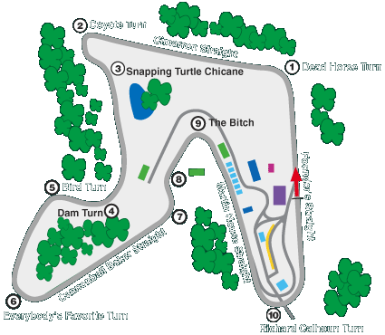
Driving School
$50 per Person (Pre Registration only)
(in Addition to the cost of the Play Day)

We are offering a 1 hr classroom introduction to racing and the track, followed by several 20-minute track sessions with one-on-one instruction from some of NCCC’s and the Southwest Region’s best teachers and drivers. You will have up to 2 hrs total of track time, so we will run several 20 minute training sessions.

After successfully completing the course you will receive your NCCC High Speed Certificate.

Note: If you currently have hour High Speed Certification but would like to participate in the school, or the one-on-one sessions, that will be available. At the same $50 per person cost.

Schedule: 6:30 Gates Open, Tech Inspections until 8:30
8:30 Classroom Instruction / Drivers Meeting
9:00 Open Practice – Multiple Cars on track, passing on straights ONLY
4:30 Track Closes
Mail this form and payment to: John Sharp PO Box 206, Broken Arrow, OK 74013

Entrant(s):______________________________________________________________________
Address:________________________________________________________________________
Phone:________________________________ Car Class:_______________Car Color_______
(Note: the cost is per car, you can have as many drivers as you like!)

13.2 NCCC OFFICIAL FLYER OUTLINE

SANCTION # SW-2007-44-45-46 TYPE OF EVENT: Record Drags and 2 ET Drags

DATE: April 22, 2007
(IF DRAG RACES INCLUDE RAIN DATE) (IF RALLYE INCLUDE RALLYE TYPE)

REGISTRATION: OPENS: 8:00 AM CLUB: CCO

CLOSES: 9:00 AM REGION: SW 423

DRIVERS MEETING TIME: 10:15 AM ENTRY FEE: $25.00 - $30.00

FIRST CAR OUT TIME: 10:30 AM LOCATION: Tulsa Raceway Park

SPEED EVENTS: *HIGH SPEED LOW SPEED:
EXHAUST: OPEN: Yes CLOSED:

MAP AND EVENT INFORMATION:
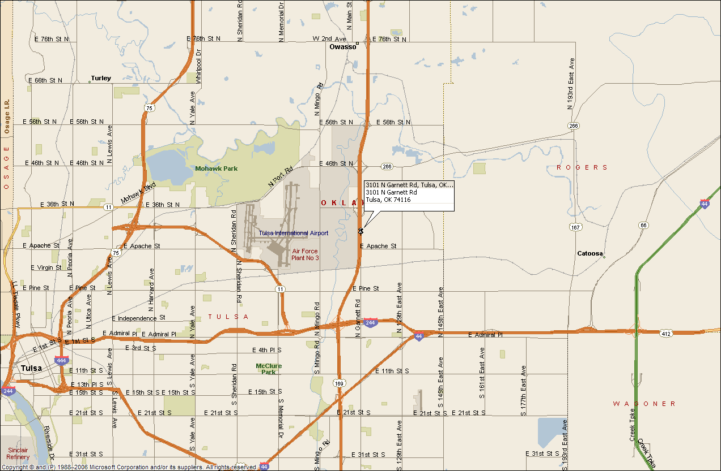
Directions to the Drag Strip:

The track is east of the Tulsa International Airport, North East of Downtown Tulsa.

East Tulsa, take Hwy 169 north from I-244 or I-44

You’ll pass the track on the right. Exit on NE 36th Street, and go back South on Garnett to the track.

BE SURE TO INCLUDE A LOCATION MAP-REVERSE SIDE MAY BE USED
EVENT CHAIRPERSON: GOVERNOR:
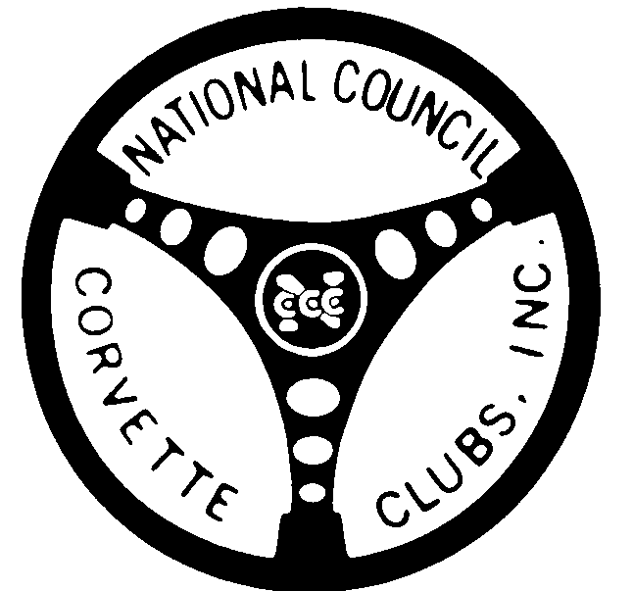
NAME: Dale Acker NAME: Doug Garrison

ADDRESS: _2811 E. 97th Place Apt_1602_________ ADDRESS: 11903 E. 121st St. North

____Tulsa, OK 74137________________________ Collinsville , OK 74021-2110__

PHONE #: 918-230-4939______________ PHONE #: 918-371-4924__________

*NOTE: In High Speed Events: 1.All roadsters must have roll bars as outlined under Section on Technical
Inspection For High Speed. 2. Fire extinguisher (min.5 BC) required in all groups and classes.
3. It is highly recommended (required in Group III) that all competing cars be equipped with roll
bars or roll cages. 4. All entrants must be high speed Certified and fire suits are required for Group III.

13.2 NCCC OFFICIAL FLYER OUTLINE

SANCTION # SW-2007-49,48,47 TYPE OF EVENT: I LS & 2 HS Autocross

DATE: April 21, 2007
(IF DRAG RACES INCLUDE RAIN DATE) (IF RALLYE INCLUDE RALLYE TYPE)

REGISTRATION: OPENS: 7:00AM CLUB: CCO

CLOSES: 8:30 AM REGION: SW 423

DRIVERS MEETING TIME: 8:30 AM ENTRY FEE: $35.00 - $45.00

FIRST CAR OUT TIME 8:45 AM LOCATION: Hallett Motor Racing Circuit

SPEED EVENTS: *HIGH SPEED X LOW SPEED: X
EXHAUST: OPEN: X CLOSED:

MAP AND EVENT INFORMATION:
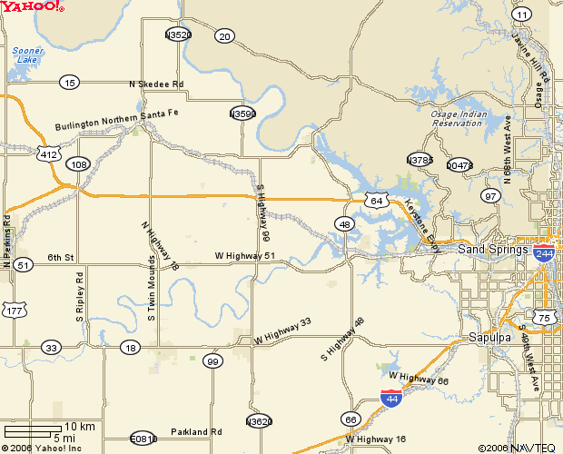
Directions to Hallett Motor Racing Circuit:

The track is WEST of Tulsa on Hwy64, or the Cimarron Turnpike and the intersection of North HWY-99

If coming up from Oklahoma City, take Hwy99 north at Stroud, about half way up the turnpike between OKC and Tulsa

BE SURE TO INCLUDE A LOCATION MAP-REVERSE SIDE MAY BE USED
EVENT CHAIRPERSON: GOVERNOR:
NAME: Dale Acker NAME: Doug Garrison

ADDRESS: _2811 E. 97th Place Apt. 1602_______________ ADDRESS: 11903 E 121st St. North

____Tulsa, OK 74137________________________ Collinsville , OK 74021-2110____

PHONE #: 918-230-4939______________ PHONE #: 918-371-4924______________

*NOTE: In High Speed Events: 1.All roadsters must have roll bars as outlined under Section on Technical
Inspection For High Speed. 2. Fire extinguisher (min.5 BC) required in all groups and classes.
3. It is highly recommended (required in Group III) that all competing cars be equipped with roll
bars or roll cages. 4. All entrants must be high speed Certified and fire suits are required for Group III.

